# RAD MODEL

# RAD which is abbreviated as Rapid Application Development Model, is based on the concepts of both iterative and prototyping development model. The Rapid Application Development model basically take prior attention on assembling customer desires in the course of workshop and development, and there is an emphasis on early testing of the system's prototype by the client or consumer using iterative methodology, then if based on the feedback - reuse the existing prototype(s) and stays in constant assimilation as well as rapid delivery. Here, in this model, the modules and pieces, as well as various functions, are developed in parallel in the form of mini projects to save the development time. These models and functions are boxed together, delivered and further assembled to form a working prototype.

The five stages of rapid application development (RAD) model are:

1. **Business Modeling Phase**: The processed data flow is recognized from varieties of business perspective.
2. **Data Modeling Phase**: Information that is taken from business modeling is then implemented for defining elements which are required for the business.
3. **Process Modeling Phase**: Data modeling achieved after assimilating details from business information flow needs to be appropriately processed to come up with a prototype.
4. **Application Generation Phase**: Various autonomous tools are employed for converting process models to code which is then finally converted to the actual system.
5. **Testing and Turnover Phase**: All interfaces and modules are tested.

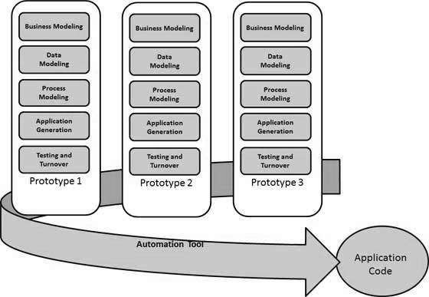

## Benefits of Using RAD model

* Reusability of components makes or speeds up the development and reduces the time that it needs for developing a product.
* The modularized way of crafting each function within the system makes the development task easier.
* Large projects can be done easily through the RAD model.

## Drawbacks of Using RAD model

* A proper time-frame should have to be maintained for both end customer as well as developers for completing the system.
* RAD model-based software development fails because of a lack of commitment and dedication.
* A slight complexity in the modularizing in RAD model can lead to failure of the entire project.